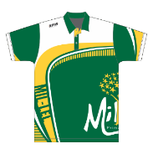

**Mil Lel Primary School  
Uniform Order Form**

**Mil Lel Primary School**

**Uniform Order Form**

Name: _________________________________________________________

Phone: _________________________________________________________

Email: __________________________________________________________

Childs Name / Class: ______________________________________________

|  |  |  |  |
| --- | --- | --- | --- |
| Item Description | Size | Qty | Amount |
|  |  |  |  |
|  |  |  |  |
|  |  |  |  |
|  |  |  |  |

Polo & Hoodies include embroidery.  
Sizes 4, 6, 8, 10, 12, 14, 16   
(Adult sizes available at extra cost)

Bucket Hat   
**$10**  
Sizes XS - XL

Sports Polos **$32.50  
ORDER VIA**[**https://www.xpressigns.com.au/club-portal**](https://www.xpressigns.com.au/club-portal)

Mil Lel Primary School uniforms are organised and ordered through our wonderful Parent Club.

Orders are placed once a term in Week 5. (Late orders are unable to be accepted)

**Sports Jackets will only be ordered once a year in term 4, week 5 due to a minimum number of order requirements. (Sports Jackets can be ordered this term only)**

We do keep a small number of uniforms in stock. So please ask if you’re in need.

Other uniform items, eg: track pants, shorts, skirts, dresses etc. can be purchased from Big W, Kmart, Best & Less, Target. Embroidery can be done at Hip Pocket Mount Gambier.

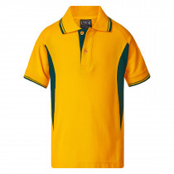

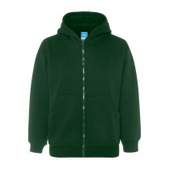 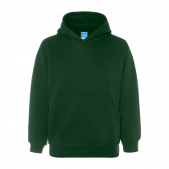

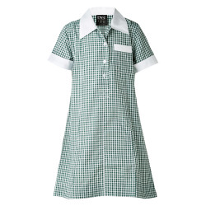 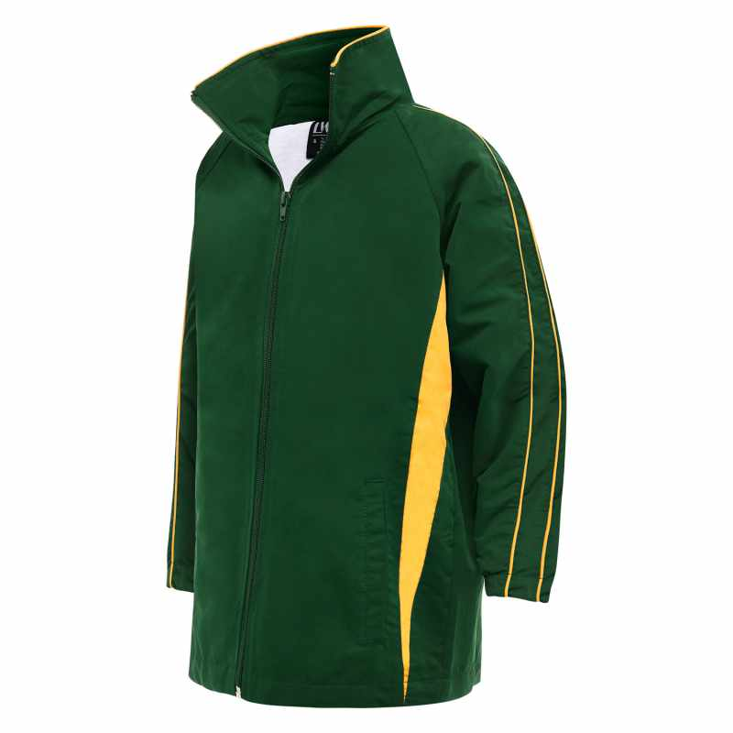

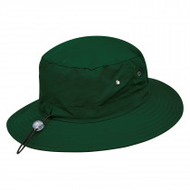

Sports Jacket **$40.00**

Summer Dress **$25.00**

Hoodie

**$35.00**

How to Place Order:

Email order to: [mps.uniforms@outlook.com](mailto:mps.uniforms@outlook.com)

Contact person: Melissa Shanks

Payment Direct to: BSB 105-002 ACC 041-101-540

Using Name for Reference eg: Smith Uniform

OR Alternatively: Give Form and Correct Money to School Front Office

*Orders must be made via the uniform email address or by submitting the form to the Front Office, social media orders not accepted.*

Short Sleeve Polo Long sleeve   
**$25.00 $30.00**

Gold/Bottle Green

Zip Hoodie **$35.00**

